**Bank Reconciliation Process**

**Client: Bangladesh’s construction steel manufacturing company**

## **Background**

Bangladesh’s top construction steel manufacturing company and one of the prominent corporate houses in Bangladesh products have been used in some of the country’s largest construction projects. The client dealt with over 30 banks in day-to-day commercial transactions. Bank reconciliation being the ubiquitous type of process was one of the biggest business challenges being faced by the company, as the process involved a series of steps that were carried out manually. This made the process time-consuming, complex and a tedious task to handle.

## **Challenges**

The process of bank reconciliation was very labour intensive, as dealing with a bigger number of account types, payments, time zones and manually matching the transaction would make the process complicated and expose the business to error and financial risks. Hence, the client desired to get rid of the daily manual processing reconciliation and automate the whole process using RPA, thus improving the operational efficiency.

## **Proposed Solution**

The solution automated the numerous manual steps in compliance with the financial standards. In addition, it also helped with exception management and added a security layer in the process. The different discrepancies and huge volume data were managed and fixed efficiently by the bot. The automation saved time and resources, helping the client to focus more on value-driven tasks.

**Benefits**

* **Turnaround time reduction** – For a 1000+ line-item reconciliation at one bank, the bot needed approximately 10 minutes, which is 70% faster than the manual execution time.
* **Optimization of resource and reduced cost pressure** – This automation resulted in effort savings of at least 5 full-time employees and reduced dependency on manual intervention.
* **Greater accuracy** – Improved process accuracy as the software bot performed all actions based on designated business rules without error.
* **Audit and Compliance** – The solution also comes with a built-in process audit functionality that keeps track of all transactions being performed by the bot. This helped them adhere to internal as well as external audits.

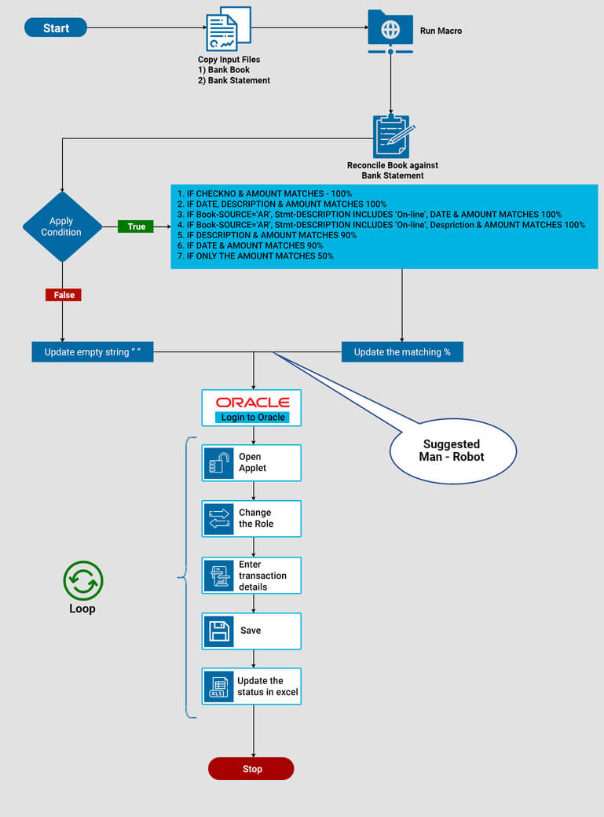

## **References**

* <https://automationedge.com/the-role-of-rpa-in-streamlining-the-bank-reconciliation-process/>
* <https://research.aimultiple.com/robotic-process-automation-use-cases/>
* https://vimeo.com/314467161